Welcome to week 3 of our Holiday Club. 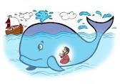

This week we are exploring Jonah’s journey. We hope you have fun reading or listening to the story. We have lots of fun activities and crafts for you to explore.

Crafts:
- Peg Jonah and the big fish
- Paper plate Jonah and the big fish
- Fishy Prayers

Games/Activities and Outdoor fun:
- Big fish den
- Jonah and the big fish game
- Moving Jonah

Fun Extras
- Banana, raisin and orange big fish

