Paul’s Boat
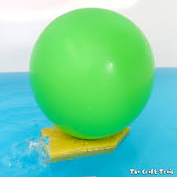
What to do
- Find the small piece of sponge (pool noodle), balloon and straw in your pack.
- Blow some air into your balloon and let it out to stretch it a little.
- With an adult make a hole in the centre of the sponge and put your balloon through the hole.
- Now cut a piece from your straw and attach to the bottom of your balloon.
- Blow air into your balloon through the straw and place it in a basin of water. Watch it travel around.
Think about
- During this activity you could think about how Paul travelled to different places to share the good news about Jesus.
Paul’s Shipwreck
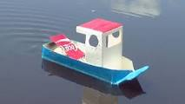
What to do
- Use junk materials form your home (bottles, boxes, cartons) to make a boat.
- As Paul was travelling in his boat there was a huge storm and they ended up shipwrecked. Can you make waves in the water to show what might have been happening to the boat in the storm?
Think about
- God was with Paul during this storm. God will be with us too when we face difficult situations in our lives.
Chains
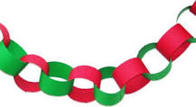
What to do
- Use strips of card/paper from your pack to make a large paper chain. You can loop the strips through each other and fasten them using sellotape or glue.
Think about
- During this activity you could think about Paul and Silas being chained up in prison for sharing the Good News about Jesus.
- Even in this very difficult situation, Paul and Silas continued to trust God and to praise him.
- This helped them to share the Good News about Jesus with other prisoners.
- We can share the Good News with others we meet too.
Hands in chains
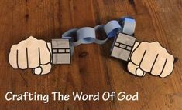
What to do
- Use strips of card from your pack to make a large paper chain. You can loop the strips through each other and fasten using sellotape or glue.
- Now draw round your hands and attach them to each end of your chain.
- On each hand you could write something that you would like to ask God for help with.
Think about
- During this activity you could think about Paul and Silas being chained up in prison for sharing the Good News about Jesus.
- They continued to trust God.
- We can ask God to help us in difficult situations too and trust that he will be with us.
Edible Snake
What to do
- Collect your biscuits from your bag. Crush them up to represent twigs/soil.
- Now collect your jelly snakes from your bag. Can you hide some snakes in the twigs/soil?
Think about
- During this activity you could think about Paul being bitten by a venomous snake with no effects. How amazing!!
- God can do amazing things in our lives when we choose to follow him on our journey!
Folding Snake 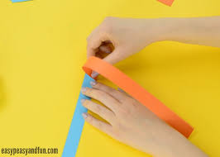 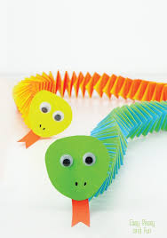
What to do
- Collect two strips of card from your bag.
- Attach them at the top at a 90 degrees angle.
- Fold the bottom strip over the top one (keeping the 90 degrees angle) and crease the fold.
- Again, take the bottom strip and fold over the top one.
- Continue until you run out of strips to fold and add some glue on the last fold.
- You can add a face to your snake.
Think about
- During this activity you could think about how people were amazed that Paul wasn’t harmed even when a venomous snake bit him.
Treasure Hunt Journey
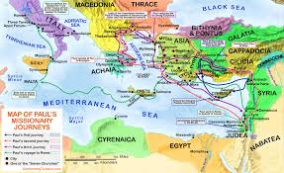
What to do
- Find your treasure hunt sheet in your pack.
- Just like Paul went on a journey to different places, use the clues on your sheet to go on your own journey.

Think about
- During this activity you could think about how Paul travelled to many places by boat to teach people about Jesus.
- God would like all of us to share this Good News today too with different people we meet.

