Peg Big Fish
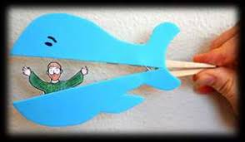
What to do
- Find the Jonah and the big fish peg template in your bag.
- Colour and cut out Jonah and the big fish.
- Attach half of the big fish to the top of the peg and half to the bottom.
- Attach Jonah at the other side.
- Now you can use the peg to open and close the mouth. Can you see Jonah inside?
Think about
- During this activity you could think about how Jonah tried to run away from God.
- He learned that he couldn’t hide from God.
- He went on to follow where God led him.
Fishy Prayers
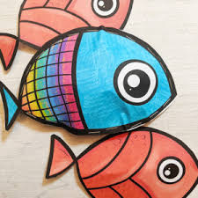
What to do
- Find your fish template in your bag.
- Decorate it on one side.
- Write your own prayer on the other side.
Think about
- During this activity you could think about Jonah praying to God when he realised he had made a mistake. What would you like to say to God in your prayer? You might like to say thank you for something, you might like to say sorry for something or you might like to ask God for help with something.
Paper Plate Big Fish
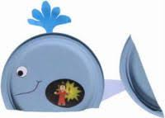
What to do
- Collect 2 paper plates and the Jonah template from your pack.
- Cut a small piece off the bottom of paper plate 1 and use this to create your tail. Cut a small oval shape out of paper plate 1 and decorate paper plate 1 to make it look like a whale (big fish). Cut out and attach the waterspout to the top of the plate.
- Cut out the picture of Jonah and add to paper plate 2 (so that it will line up with the oval cut out from paper plate 1).
- Trim paper plate 2 and attach the plates together so you can see Jonah inside the big fish.
Think about
- During this activity you could think about how, just like Jonah, sometimes we can find it hard to do what God wants us to do. We can ask God to help us.
Big Fish Den
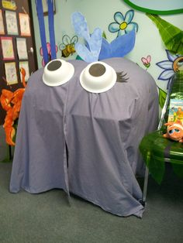
What to do
- Can you use a sheet and some junk material to make a ‘Big Fish Den?’
- We would love to see some photos of you inside.
Think about
- During this activity you could think about Jonah being swallowed by a whale.
- How do you feel when you are inside the big fish? How do you think Jonah might have felt being inside the big fish for a long time?
- Sometimes we like to hide in a den. The story of Jonah reminds us that we can’t hide from God.
Jonah Game
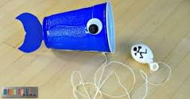
What to do
- Find your blue paper cup. Decorate it to make it look like a big fish (add the googly eye from your pack and you could also add a tail).
- Fill your small balloon with some flour and tie it. Add a face – pretend this is Jonah.
- Tie string round the balloon and attach to other end to the cup. Can you get Jonah into the cup (big fish)?
Think about
- During this activity you could think about Jonah being swallowed by the big fish.
Moving Jonah
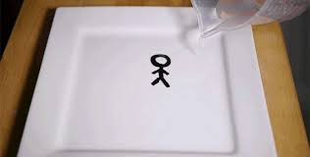
What to do
- Collect your dry wipe marker from your craft bag.
- Find a white dinner plate or white dish.
- Draw the outline of a man to represent Jonah. Draw the outline of a big fish.
- Pour on some water – what do you notice?
- I wonder if you can manage to get Jonah to float into the mouth of your big fish?
Think about
- During this activity you could think about Jonah being swallowed by the big fish.
- God had a plan for Jonah’s life. He has a plan for our lives too.

