Personal Arks
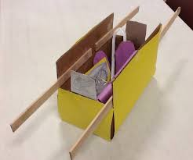
What to do
- Find a box in your home e.g. a cereal box, a shoe box or any other boxes you have for recycling.
- Cover it with paper or tinfoil and decorate with materials you have in your home – pens, stickers, jewels, tissue paper etc.
- Now cut out the 10 commandments and place them in your box (ark).
Think about
- During this activity you could think about how the Israelites made a special box (called an ark) to keep the commandments in as they travelled.
Commandments Game
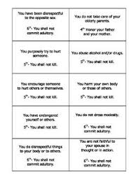
What to do
- Cut out the 10 commandments from your commandments game sheet.
- Place them all at one side of a room or garden. Now stand at the opposite side of the room/garden. Collect each commandment one at a time, running back and forward. How quickly can you do this? Can you repeat and beat your time?
Think about
- During this activity you could think about God giving Moses the 10 commandments. These commandments help us to know how God would like us to live our lives.
Commandments Scroll
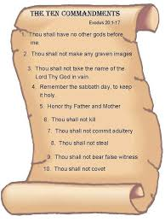
What to do
- Take a piece of white paper and rip off the edges.
- Crumple the paper into a ball and then flatten it again.
- Pour half a cup of cold tea or coffee over it and swoosh it all over the paper with your hands. Leave it to dry.
- Once it is dry write the 10 commandments on the scroll. You might like to write them using the Greek alphabet sheet in your pack.
Think about
- During this activity you could think about the 10 commandments being given to Moses long ago. They show us how God would like us to live our lives.
Compass
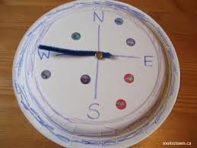
What to do
- Find your compass sheet in your pack. Cut out the circle shape and add directions - N(North), S(South), E (East) and W(West).
- Cut out the arrow and attach it to the centre of the circle using your paper fastener.
Think about
- During this activity you could think about how a compass can be used to help with directions on a journey.
- The Bible can be used to help us on our spiritual journey. Just like a compass or map it can help to show us the way to God.
Compass Prayer
What to do
- Hold your homemade compass – you can use it to help you to say a prayer.
Think about
- During this activity you could think about what shape the points on the compass make. Can you see a cross?
- Ask God to be your compass and direct you on the right path.
Directions Game
What to do
- Take your compass with you the next time you go for a walk or cycle.
- When you come to the end of a path or road, spin the needle to see which direction to go. We would love to see some pictures of your routes!
- If you haven’t made your compass yet you could toss a coin – heads go right, tails go left.
Think about
- During this activity you could think about how Moses relied on God to show him which direction to go. We can rely on God to show us which way to go in our lives too.
Fire and Cloud
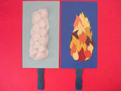
What to do
- Find your pillar templates in your pack. Stick cotton wool on one pillar to show the pillar of cloud. Now cut or tear the tissue paper from your pack and stick it onto the other pillar to make the pillar of fire.
Think about
- During this activity you could think about the Lord going ahead of Moses and his people in pillar of cloud during the day to guide them and a pillar of fire by night to guide them. God is always with us, just as he was with Moses and his people on their journey.

